This lab requires that you take a Cold Backup of your database.

The lab output that you send me does not have to be in APA format. You can send me the output from your labs in several ways:
- Capture screen shots (print screen key) and put them in a Word document
- Cut and paste output from your screen into a Word document

I won’t be too picky about the output format, just as long as I can tell that you successfully completed each recipe.

The rest of this document describes how to take a Cold Backup of your database.

Taking a Cold Backup in Citrix:

The normal procedure for taking a Cold Backup is as follows:

1. Determine the location of your datafiles, control files, and online redo log files.
2. Shutdown your database.
3. Copy the files identified in step one to a backup folder
4. Startup your database.

In Citrix, this isn’t always straightforward like it is in most other environments. This is because there is a mismatch in what you see in the data dictionary versus how the drives are actually mapped.

Login to Citrx:
http://citrix.arn.regis.edu

You should see a screen like this:

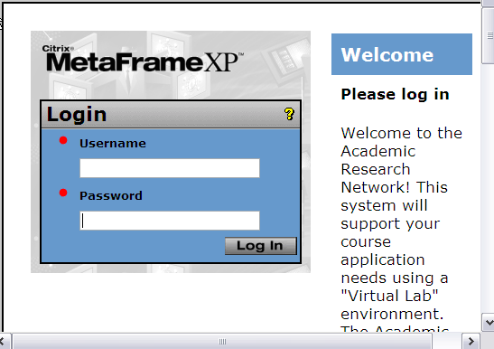

Next Click on “Oracle Desktop”

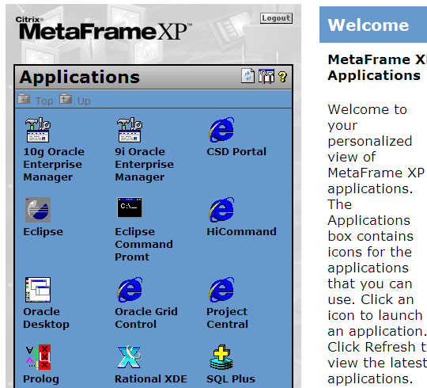

If you haven’t mapped your “Ora01” drive, then do so with the following steps:

Right click on “My Computer”
Pick “Map Network Drive...”
Pick Drive H
Click on “Browse”
Click on “Regis”
Click on “Ora01”
Click on “MSCD642”
Click on “OK”

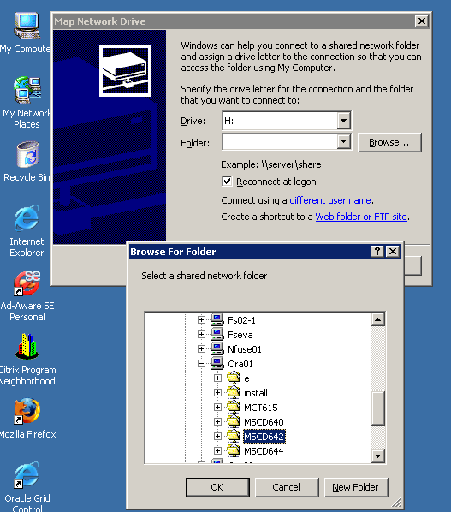

Click on “Finish”

You should now be able to navigate to where your database files are located.

Right click on “My Computer”
Choose “Explore”
Click on the folder “Mscd642 on ‘Ora01’ (H:)
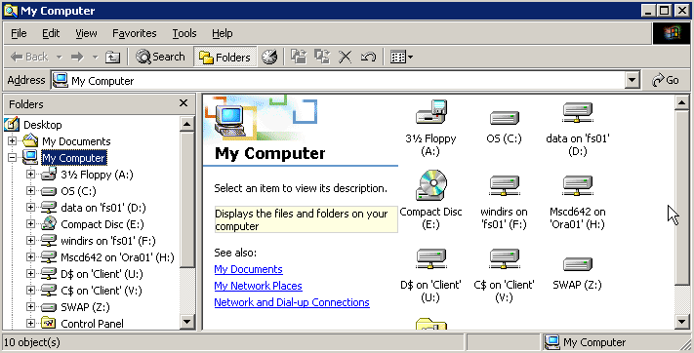

Next click on “dbms”
Next click on “app”
Next click on “admin”
Next click on “BKxyz” where xyz is your database number (in this example, the number is 101). You should now see a screen similar to this:

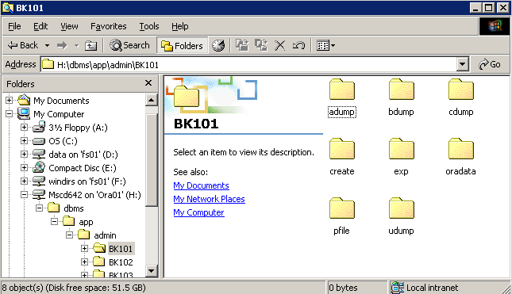

All of your database files are in folders beneath the “oradata” folder.

Create a new folder called “backups” in the same location that your “oradata” folder is located (file, new folder, backups):

You should see something similar to this now:

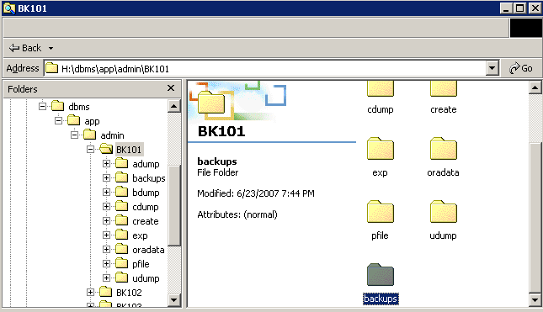

Now to take a Cold Backup:

SQL> shutdown immediate;

Now copy the “oradata” folder into the “backups” folder. To do this, right click on “oradata” and drag it over the top of “backups”, let up on the mouse, and choose “Copy Here”.

You should see a screen similar to the one shown:

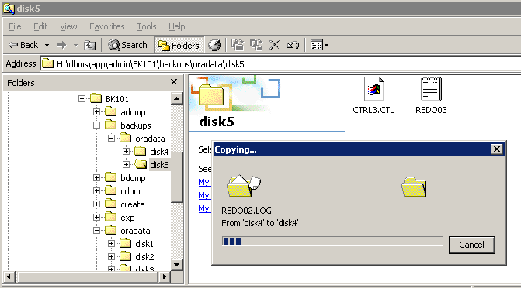

After all of the files have been copied to “backups”, then you can restart your database;

SQL> startup;

